My Unit Converter

**App Description**

The mobile app planned, will give the user the ability to convert a unit to another unit (and visa-versa). The unit conversion types, formulae's and any special rules (maybe) inside a database.

The units and their information are also going to be stored in a SQLite database, along with other related information that the program will query information from when performing calculations.

The user can also create their own unit conversions, with formula and rules (maybe).

The formula are going to have a specific rule to follow, which will be shown in a tutorial page, that the program is going to be able to understand how the conversion is done. eg: 2xaxb will perform '2' multiply 'a' multiply 'b'. Ext: the user can also remove their own custom conversion rules that they have added.

Each conversion type is going to be sorted into category, e.g.: Game, Currency, Weight, Liquid etc... This can be toggled to Show All, or Categorise (in lists).

There will also be the ability to make multiple windows, to have a conversion (result, or not yet completed) on one screen, then another window which they can easily switch to and perform another conversion.

**Use Case**

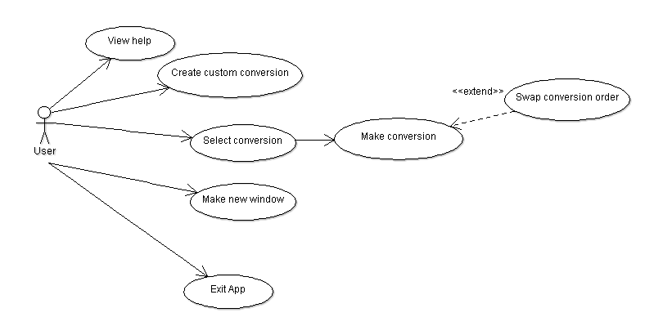

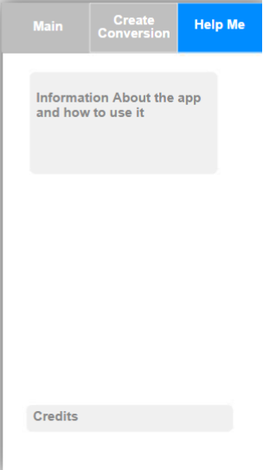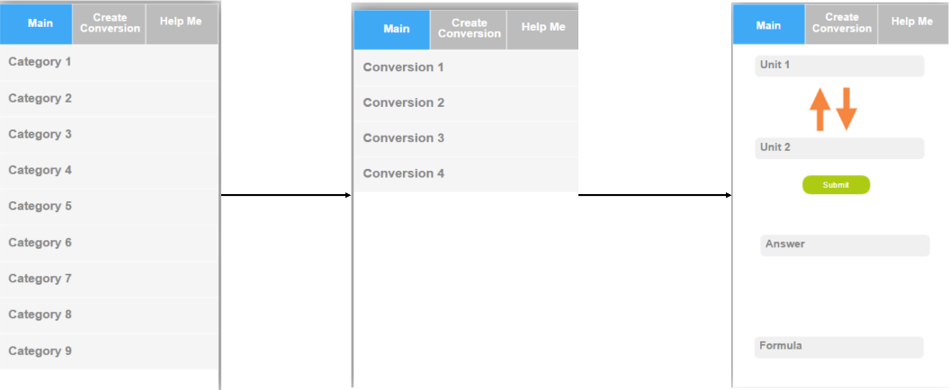**Screen Flow**

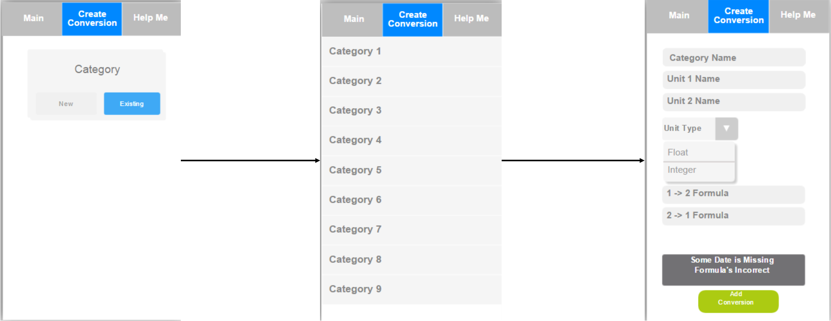

**Tables**

--may not need this table in the end; it’s a precaution.

--The screen flow may need some editing, to instead of adding the units in the same screen, make -----the units separately as part of the conversion, it’s a decision I’m going to have to make later on

Units:

UnitID Number (5),

UnitName Varchar2 (50),

CategoryId Number (5); (fk)

Conversion:

ConversionID Number (5),

Unit1ID Number (5), (fk)

Unit2ID Number (5), (fk)

toFormula Varchar2(50),

--the layout of the formula is still foggy, needs more in depth thinking in how it’s going to  
--work

Unit Type Varchar2 (10),

fromFormula Varchar2(50); (example: )

Category

CategoryID Number (5),

CategoryName Varchar2 (50);

**Main features planned**

Choose category and the conversion to perform, swap direction and perform conversions easily and fast.

Have multiple windows opened and swap from them so the user can perform multiple conversions at once (This feature is experimental at most, and may not make it into the final application)

Create custom conversions and add to or create new categories.  
 The function of how the formula system is very obscure and not completely planned out, as it is  
 going to be difficult.